Practical 6 – Graphical User Interface

Q1) Create a simple master page and add some HTML to it to define the general structure of the pages in your website

- Create a new web site in Visual Studio.
- Create the MasterPages folder in the root of the site, right-click the new folder, choose Add→Add New Item, and select the Master Page item. Make sure that the master page uses Code Behind and that it is using your preferred programming language. Name the master page Frontend.master. Finally, click Add.
- Add the following highlighted code between the <form> tags of the master page, replacing the <div> tags and the ContentPlaceHolder that VS added for you when you created the master page.

<form id="form1" runat="server">
<div id="PageWrapper">
<header><a href="/">Header Goes Here</a></header>
<nav>Menu Goes Here</nav>
<section id="MainContent">
<asp:ContentPlaceHolder ID="cpMainContent" runat="server">
</asp:ContentPlaceHolder>
</section>
<aside id="Sidebar">Sidebar Goes Here</aside>
<footer>Footer Goes Here</footer>
</div>
</form>

Make sure that you have the ContentPlaceHolder within the MainContent <section> tags. You can drag one from the Toolbox onto the page or enter the code directly, using IntelliSense’s helpful hints. In both cases you should give the control an ID of cpMainContent.
- Create a new folder and named it Styles. Import the CSS file Styles.css (given in wble) to the Styles folder. Next, switch the master page into Design View and then drag Styles.css from the Styles folder in the Solution Explorer onto the master page. As soon as you drop the file, VS updates the Design View and shows the layout for the site. If the design doesn’t change, switch to Markup View and ensure there’s a <link> tag in the head of the page pointing to your CSS file:

<asp:ContentPlaceHolder ID="head" runat="server">
</asp:ContentPlaceHolder>
<link href="../Styles/Styles.css" rel="stylesheet" type="text/css" />
</head>

The page should now look like Figure 1 in Design View.

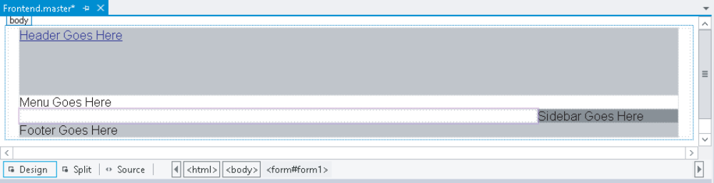
Figure 1

Note the area with the purple border around it between the menu and the footer region in your Design View. This is the ContentPlaceHolder control that is used by the content pages.
- Create a new folder and named it Scripts. Import the script file modernizr-2.6.2.js (given in wble) to the Scripts folder. Drag the file modernizr-2.6.2.js from the Scripts folder into the <head> section of the Master Page below the CSS file. Then manually replace the two leading periods with a slash, like this:

<script src="/Scripts/modernizr-2.6.2.js"></script>

- Save and close the master.

Q2) Add a content page to the site that is based on the master page you created earlier. Once the page is added, you add content to the <asp:Content> regions.

- Right-click the website in the Solution Explorer and choose Add → Add New Item. Select the correct programming language, click Web Form, name the page Default.aspx, and then, at the bottom of the dialog box, select the check boxes for Place Code in Separate File and Select Master Page, as shown in Figure 2.

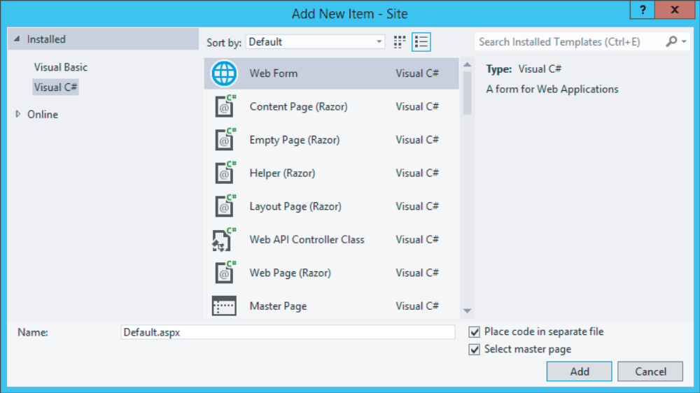
Figure 2

Finally, click the Add button.

- In the Select a Master Page dialog box (see Figure 3), click the MasterPages folder in the lefthand pane, and then in the area at the right, click Frontend.master.

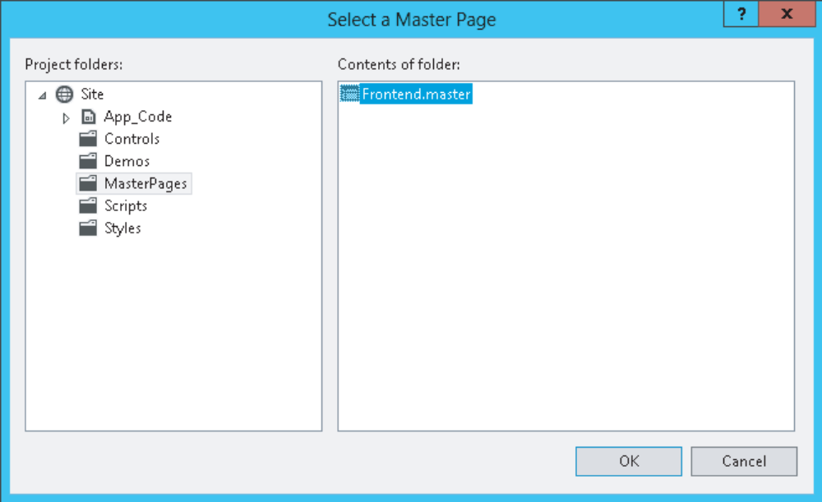
Figure 3

Click OK to add the page to your website.

Instead of getting a full page with HTML as you got with standard ASPX pages, you now only get two <asp:Content> placeholders as shown in this VB.NET example:

<%@ Page Title="" Language="VB" MasterPageFile="~/MasterPages/Frontend.master"
AutoEventWireup="false" CodeFile="Default.aspx.vb" Inherits="_Default" %>
<asp:Content ID="Content1" ContentPlaceHolderID="head" runat="Server">
</asp:Content>
<asp:Content ID="Content2" ContentPlaceHolderID="cpMainContent" runat="Server">
</asp:Content>

- Switch to Design View and note that everything is grayed out and read-only, except for the <asp:Content> region for cpMainContent. Figure 4 shows you how the page should look.

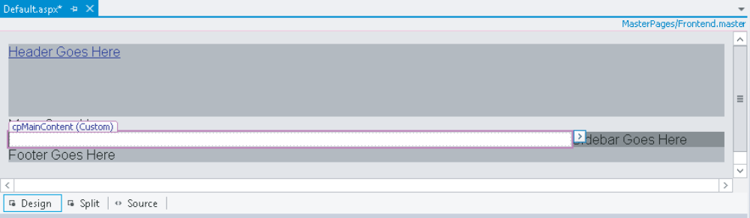
Figure 4

Also note that VS conveniently lists the master page that this page is based on in the top-right corner of Design View, visible in Figure 4. Clicking the name opens the master page in the editor.
- Place the following markup inside the cpMainContent placeholder.

<h1>Hi there visitor and welcome to UTAR</h1>
<p class="Introduction">
We&#39;re glad you&#39;re paying a visit to <a href="http://www.utar.edu.my">www.utar.edu.my</a>, the coolest university site on the Internet.
</p>
<p class="Introduction">
Feel free to have a <a href="Default.aspx">look around</a>; there are lots of interesting <strong>reviews and pictures</strong> to be found here.
</p>

- Save your changes by pressing Ctrl+S and press Ctrl+F5 to open the page in your browser. The browser should display the page very closely to what you saw in Design View (see Figure 4).
- Now take a look at the HTML for the page in the browser. You can do this by right-clicking the page and choosing View Source or View Page Source. Note that the source of the final page in the browser is a combination of the source of the master page and the content page:

<div id="PageWrapper">
<header><a href="/">Header Goes Here</a></header>
<nav>Menu Goes Here</nav>
<section id="MainContent">
<h1>Hi there visitor and welcome to UTAR</h1>
<p class="Introduction">
We&#39;re glad you&#39;re paying a visit to <a href="http://www.utar.edu.my">www.utar.edu.my</a>, the coolest university site on the Internet.
</p>
<p class="Introduction">
Feel free to have a <a href="Default.aspx">look around</a>; there are lots of interesting <strong>reviews and pictures</strong> to be found here.
</p>

The first four lines come from the master page and the bolded lines of HTML code come from the content page.

- Switch back to VS and create a new page called Login.aspx in the root of the site based on the master page. Notice how VS remembered your last settings with regard to the master page and Code Behind (make sure both are checked in case you unchecked them earlier). Switch to Markup View and create an <h1> element inside the cpMainContent placeholder with the text Log in to UTAR. There’s no need to add any other controls to this page.
- Go back to Default.aspx and switch to Design View. Beneath the welcome text with the header and two <p> elements, create a new paragraph (press Enter in Design View) and type some text (for example, You can log in here). Notice how this new paragraph has a class attribute called Introduction because VS applies the previous class to new paragraphs automatically. Remove this class using the Clear Styles option of the Apply Styles window, or manually remove it from the code in Markup View.
- Highlight the words “log in” in Design View and choose Format→Convert to Hyperlink from the main menu. In the dialog box that follows, click the Browse button and select the Login.aspx page that you just created. Click OK twice.
- Save all changes and press Ctrl+F5 again to view Default.aspx in the browser. Then click the link you created in the preceding step. You should now be taken to Login.aspx. Note that the general layout, like the header and the sidebar, is maintained. The only thing that changes when you go from page to page is the content in the main content area.

Q3) Create two themes: Monochrome and DarkGrey. For each theme, add the CSS layout, which is applied to the site automatically. Configure the application to use one of the themes.

- Add the special App_Themes folder to your website. To do this, right-click the website in the Solution Explorer and choose Add→Add ASP.NET Folder→Theme. This not only creates the App_Themes folder, but immediately creates a subfolder for the theme called Theme1 by default. Type Monochrome as the new name instead. Your Solution Explorer should now look like Figure 5.

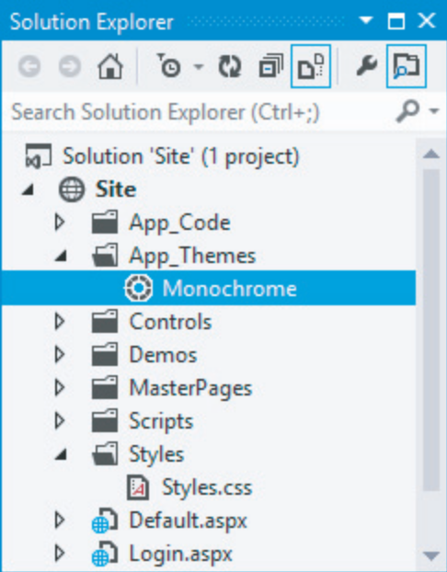
Figure 5

- From the Styles folder, move the Styles.css fi le into this new Monochrome folder. You can either drag it directly into the new folder or use Ctrl+X to cut the fi le, click the Monochrome folder, and press Ctrl+V to paste it again. You can leave the empty Styles folder because it’s used again later.
- To make it clear later where your CSS is coming from, rename the fi le from Styles.css to Monochrome.css. You can rename it by selecting it and pressing F2 or by right-clicking it and choosing Rename.
- Because the main layout is now going to be controlled by the theme, you no longer need the <link> element in the <head> section of the master page pointing to the old CSS file, so you can remove it. To this end, open the master page, switch to Markup View, and remove the following highlighted line from the code:

<head runat="server">
<title></title>
<asp:ContentPlaceHolder ID="head" runat="server">
</asp:ContentPlaceHolder>
<link href="../Styles/Styles.css" rel="stylesheet" type="text/css" />

- The next step is to apply the theme to the entire website. Open the Web.config file from the root of the site and directly inside the <system.web> element, create a <pages> element with a theme attribute pointing to the Monochrome theme. There’s no support for themes in IntelliSense in the Web.config file so you need to type the name yourself.

<system.web>
<pages theme="Monochrome" />
...

- To test the theme, save all your changes and then request the Default.aspx page in your browser. The design of the site should be identical to how it was. Instead of linking to the CSS file from the master page, the CSS is now included in the page source through the theme set in the Web.config file. To see how this works, open the HTML source of the page in the browser. At the top you should see the following code:

<!DOCTYPE html>
<html xmlns="http://www.w3.org/1999/xhtml">
<head>
<title>Welcome to Planet Wrox</title>
<script src="/Scripts/modernizr-2.6.2.js"></script>
<link href="App_Themes/Monochrome/Monochrome.css" type="text/css" rel="stylesheet" />
</head>
<body>

Note that a link to the style sheet from the Monochrome theme folder is injected in the <head> of the page. The ASP.NET run time does this for every CSS fi le it finds in the currently active theme folder (in alphabetical order), so be sure to keep your theme folder clean to avoid unnecessary files from being included and downloaded by the browser. Also note that the <link> is added just right before the closing </head> tag. This ensures that the theme fi le is included after all other files you may have added yourself (through the master page, for example). This is in contrast to how the styleSheetTheme attribute works. Because this type of theme allows its settings to be overridden, it’s imported at the top of the fi le, giving room for other CSS fi les that follow it to change the look and feel of the page.
- Return to Visual Studio and open the master page fi le in Design View. Notice how all the design is gone and VS now shows the basic layout of the page again. Unfortunately, VS does not display the theme you’ve set using the theme attribute. However, you can overcome this limitation by setting the styleSheetTheme instead. To do this, open the Web.config file again, locate the <pages> element you created earlier, and add the following attribute:

<pages theme="Monochrome" styleSheetTheme="Monochrome" ... />

- Save the changes to Web.config, close and reopen the master page, and switch to Design View. You’ll see that VS now applies the correct styling information to your pages.
- Add another theme to the site and call it DarkGrey. Drag the file DarkGrey.css (you can obtain from wble) into the DarkGrey theme folder in VS. Your Solution Explorer should now resemble Figure 6.

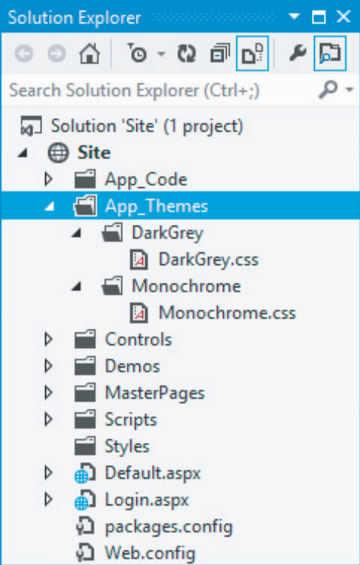
Figure 6
- Open the Web.config fi le once more and change both occurrences of Monochrome to DarkGrey in the <pages> element. Save the changes again and press Ctrl+F5. Instead of the blue Monochrome theme, you’ll now see the site with the DarkGrey theme applied as is visible in Figure 7. If you don’t see the menu placeholder, the main content, and the sidebar all next to each other, make sure your browser window is wide enough to display all content.

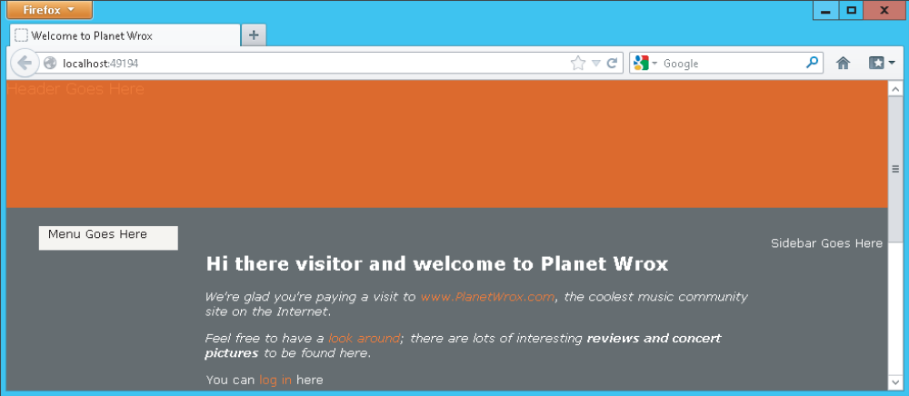
Figure 7

If you don’t see the new theme appear, close all open browsers, ensure you changed Web.config correctly, and open Default.aspx again. If you still don’t see the theme, press Ctrl+F5 or Ctrl+R in your browser to force it to get a fresh copy from the server.

Part 2: Try on your own

Q4) (a) Create a skin for Button that uses a combination of inline attributes for styling (the BackColor to Blue) and the CssClass to point to the selector, MyButton in the Monochrome.css CSS file. MyButton selector will set the text color to white.
(b) Create a web form called SkinsDemo.aspx with the necessary code behind the page that applies the master page. The web form should have a DropDownList and a Button in it as shown in Figure 8.

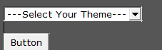
Figure 8

The DropDownList has THREE (3) options for users to choose from namely “---Select Your Theme---“, “Monochrome” and “DarkGrey”. When a selection is made from the DropDownList, the correct Theme will be applied to the page and the DropDownList will be showing the user’s selection.

